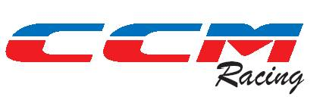

Are offering four (4) special package deals for 2012 on TM / Gas Gas Machinery. The basis will be
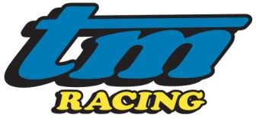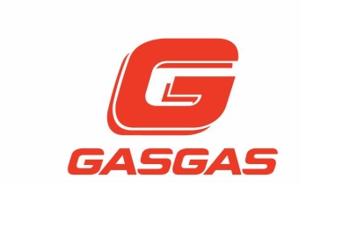
- The customer will purchase the bike (NO TRADE IN) at a discounted RRP price .
- CCM will guarantee to purchase the bike back at the end of season (or at an agreed date) at a fixed price corresponding to a low depreciation value.
- CCM will warrant all priority parts for the season against breakage (subject to correct and specified maintenance procedures), and offer all wear items at a special discounted cost. Tyres excluded. It will be the customer responsibility to replace parts as they fall due IE Clutches, pistons, rings etc etc .
- Crash and or Abuse damage/ Breakages will be the responsibility of the customer and it will be the customer responsibility to ensure that plastics / graphics / tyres/ chains, sprockets bearings etc etc are in good condition and that at the buyback date and that the bike is in good running order and saleable condition . Reasonable conditions will apply.
- Should the customer wish to extend the “deal” period past the agreed season date we will look at a favourable response.
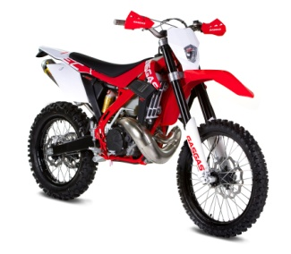
- The offer is open to all riders/ grades but will be on a first come basis with an agreed deposit.

Bikes will be limited to the following and delivery dates subject to factory delivery
Gas Gas ………… 250 / 300 EC
TM ……..125/ 144 / 250 2t; 250 Fi 4 T.
IN addition CCM will offer 2 + 2 additional models plus spares package at a very discounted cost. Again on first come basis.
Both TM and Gas Gas have new models for 2012. Surprise yourself with how good they are.
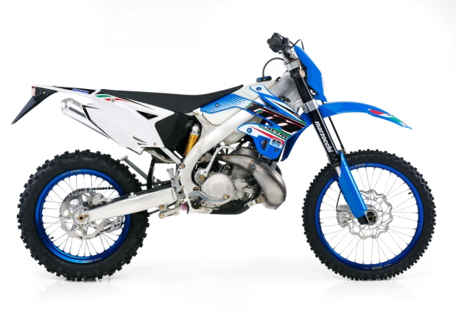
Contact Nick or Gavin for details
2012 Models Depicted

.

